Linkdin

[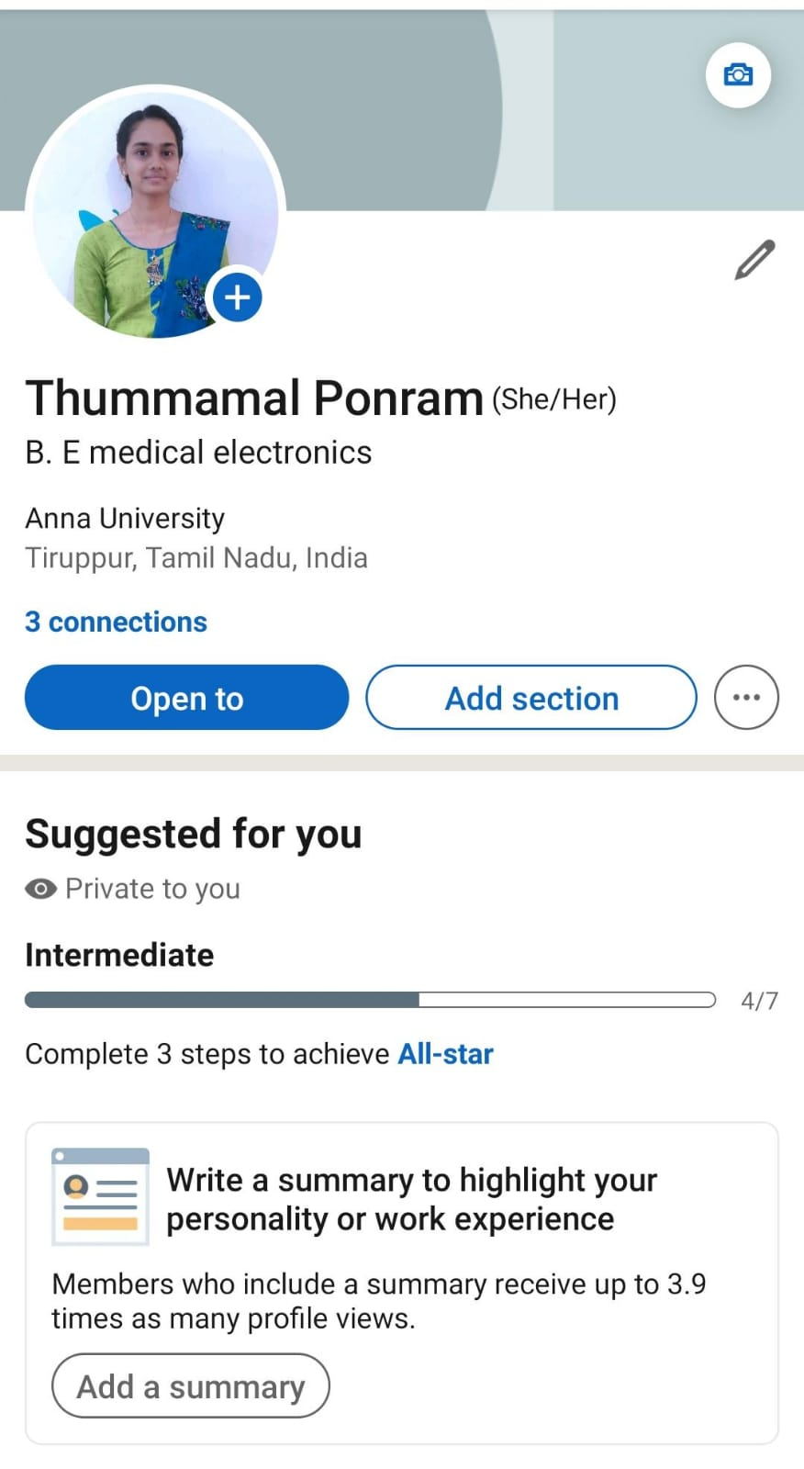](https://www.linkedin.com/in/thummamal-ponram)https://www.linkedin.com/in/thummamal-ponram

Facebook Ad

[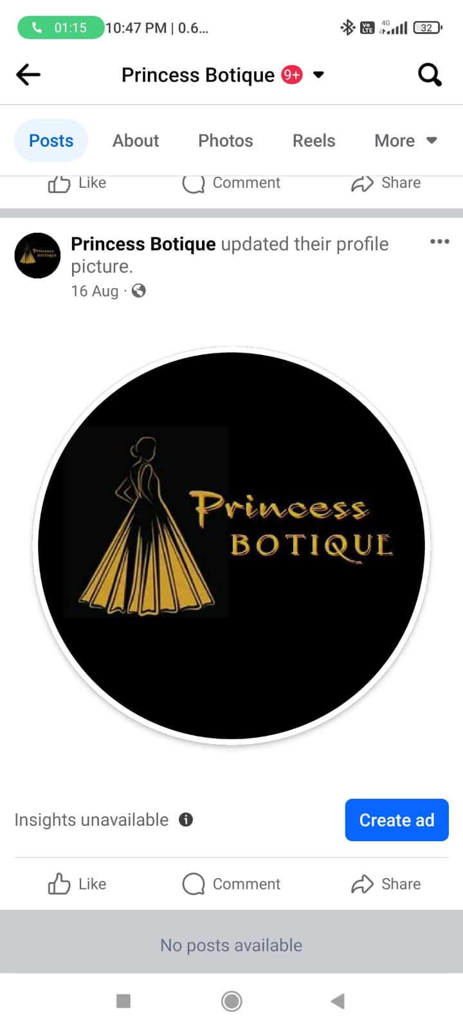](https://www.facebook.com/profile.php?id=61550039525538&mibextid=ZbWKwL)https://www.facebook.com/profile.php?id=61550039525538&mibextid=ZbWKwL

Email newsletter

[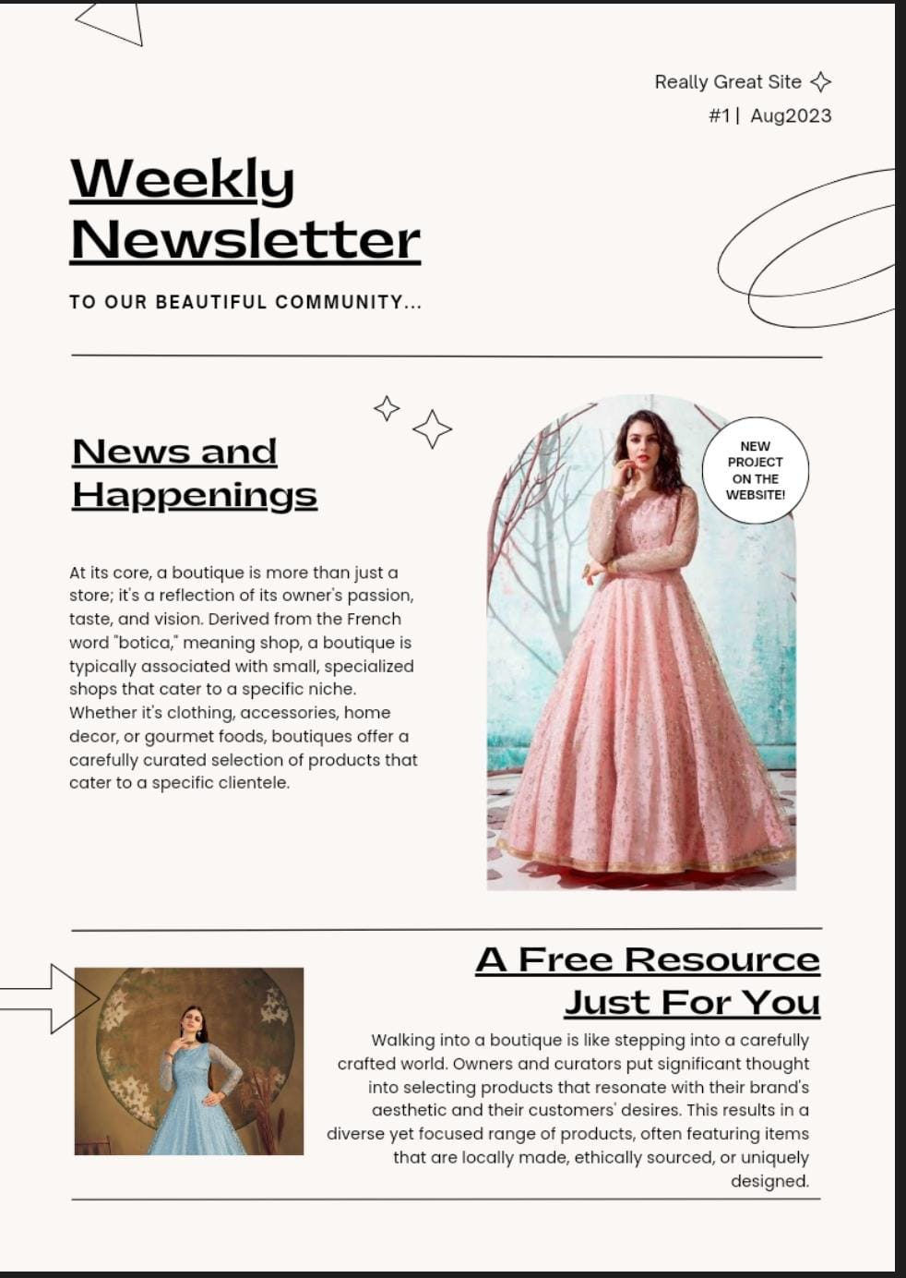](https://princessbotique2.wordpress.com/2023/08/30/email-news-letter/)https://princessbotique2.wordpress.com/2023/08/30/email-news-letter/

[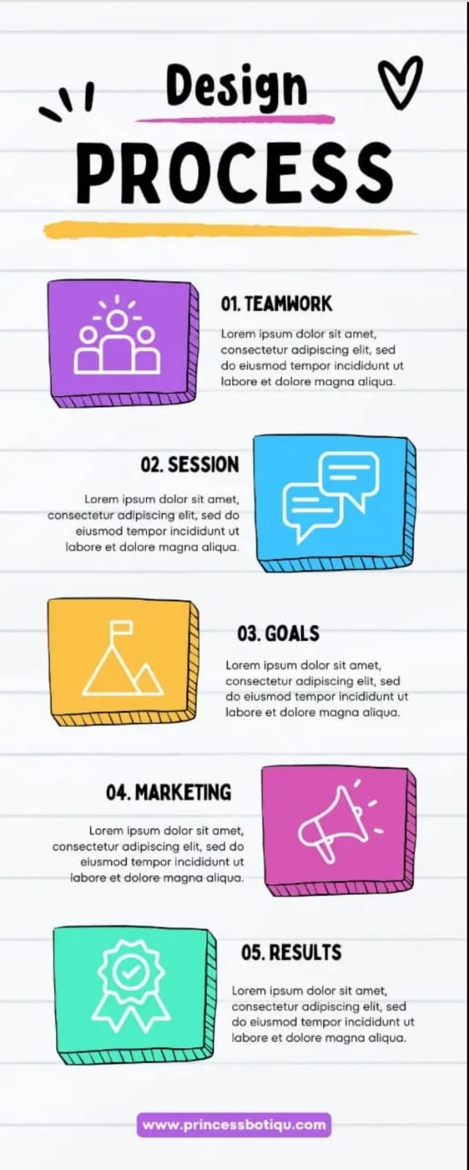](https://princessbotique2.wordpress.com/2023/09/02/design-process-infography/)https://princessbotique2.wordpress.com/2023/09/02/design-process-infography/

Infography

[](https://princessbotique2.wordpress.com/2023/08/23/my-botique/)https://princessbotique2.wordpress.com/2023/08/23/my-botique/

Blog

Google Analytics

[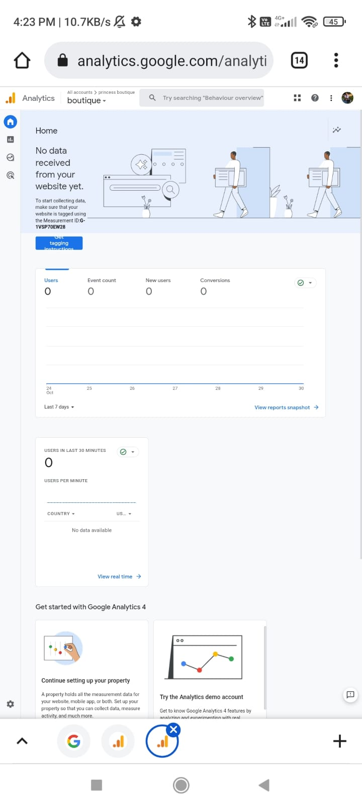](http://G-1VSP70EW28/)http://G-1VSP70EW28/